Experiment No.: 1
Modeling using xADL
Learning Objective: Student should be able to do Modeling using xADL
Tool:- Apigen , Data Binding Library, StarUML
Theory:
xADL is a software architecture description language (ADL) that is extremely extendable. It is used to explain many features of a software system's architecture. A software system's architecture is its high-level design; design at the level of components, connections, and their combinations. The heart of xADL, like that of other ADLs such as Rapide, Darwin, and Wright, mimics the four most prevalent architectural structures, namely:Components : (the loci of computation),
- Connectors : (the loci of communication),
- Interfaces : (the exposed entry and exit points for components and connectors), and
- Configurations : (topological arrangements of components and connectors as realized by links).
- xADL is an XML-based programming language. XML, or eXtensible Markup Language, was designed to annotate or "mark up" text documents with semantic information. Tags, or special strings that delimit a segment of text, are used to mark up text elements. Tags are denoted by an open angle bracket () and a closed angle bracket (>). Tags in XML documents are typically used in pairs to represent the beginning and end of a text element. Start tags have a tag name right after the opening angle bracket, and end tags have the same name, but preceded by a forward slash (/). Elements can be stacked as needed, but they cannot overlap. Here's an example of some XML-marked text:
<name><first>Herb</first> <last>Mahler</last></name>
- To HTML users, this format may look familiar. This is because XML and HTML both share a common historical ancestor, SGML (the Standard Generalized Markup Language). In HTML, however, there is a finite set of allowed tags, each of which has a specific meaning dedicated to screen layout. So, tags like <H1> in HTML indicate that a text element is to be laid out in the Heading 1 style (usually large and bold, although this varies depending on the layout engine used), but do not indicate any other semantics about the element--is it a story headline? Is it someone's name? This information is not present in HTML.
- This lack of a static set of allowed tags introduces a new problem into XML applications. What tags are allowed and what do they mean? How do two parties sharing marked-up documents come to an agreement on what elements are allowed, and where? How can they ensure that their information is marked up in a consistent way that is meaningful to both of them?
- The solution to this dilemma is to create a meta-language, which is a language for creating languages. Meta-languages in XML determine which elements are allowed, where they can occur (and what their cardinality is), and what data can be part of each element. The XML 1.0 standard featured a meta-language known as the DTD (Document Type Definition). The DTD meta-language was adequate for describing XML-based languages as a collection of production rules, similar to a BNF (Backus-Naur Form) grammar, but it proved unsuitable for other applications. To address some of the concerns that users had with DTDs, the W3C (World Wide Web Committee) created XML Schema, a new meta-language for XML. XML schemas are more expressive than DTDs, they have an XML-like syntax (DTDs do not), and they allow type relationships among element types much like object-oriented inheritance.
- The creation of XML schemas made it more easier for developers to construct and expand XML-based languages, and also aided in the development of modular languages such as xADL. A comprehensive discussion of XML is considerably beyond the scope of this guide.
- xADL's XML basis means that data in xADL is arranged hierarchically. Connections between data elements that are not hierarchically arranged are managed using simple XML links; xADL's tool support facilitates navigating these links.
- xADL documents are readable and editable by hand as ordinary text documents since they are written in an XML-based language. The actual code, however, can get fairly involved because xADL is specified in numerous schemas, each with its own XML namespace. For example, consider the following xADL component description:

The xADL Type System

xADL adopts the more traditional types-and-instances model found in many programming languages. In this model, components, connectors, and interfaces all have types (called component types, connector types, and interface types, respectively).
Links do not have types because links do not have any architectural semantics. The relationships between types, structure, and instances are shown in the following table:
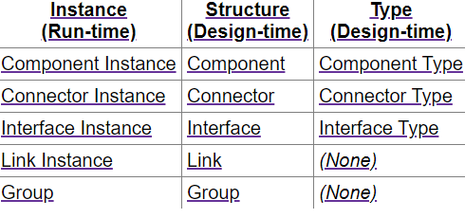
- Component Types
  - Sub architectures for Component Types
  - Signatures
- Connector Types*
  - Sub architectures for Component Types
  - Signatures
- Interface Types

Modeling of xADL
With the instances schema, xADL may simulate running instances of architectural constructs like as components, connectors, interfaces, and linkages. However, much work on software architecture is focused on architecture design rather than capturing aspects of a running one.
We distinguish between architectural instances that exist at run-time and structural components that exist at design-time for the sake of this study.

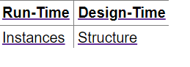
The xADL constructs available for modeling architectural structure mirror almost exactly those available for modeling architecture instances. The constructs defined in the instance schema are:
- Components
- Connectors
- Interfaces
- Links
- General Groups
Structure of design-time architecture

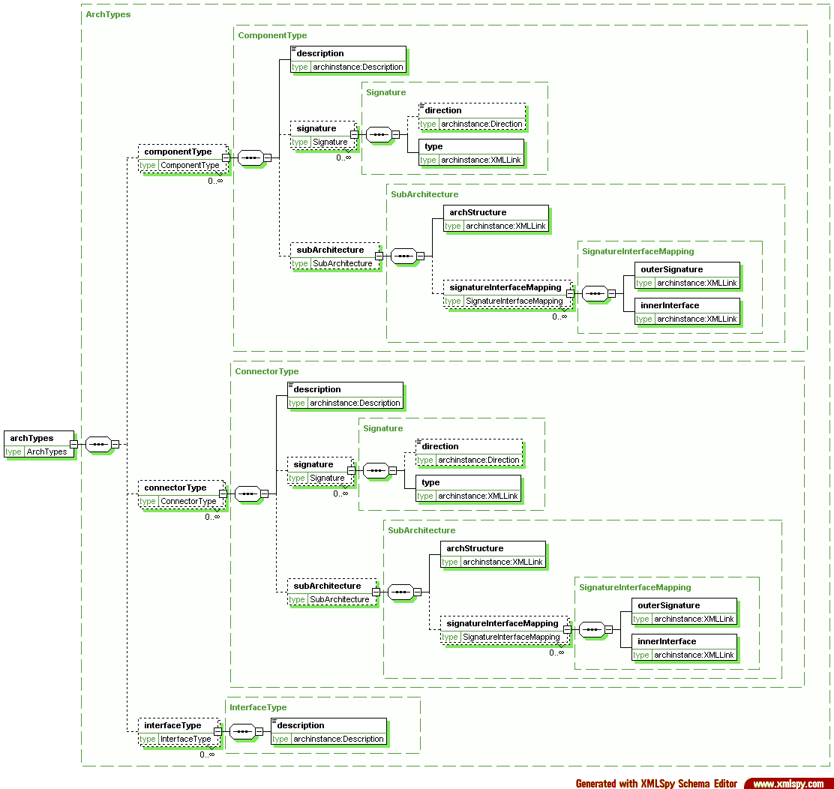

"component" is used as a structural construct, as opposed to "component instance," which is used to describe a run-time instance. Similarly, "connector," "interface," and "link" are used instead of "connector instance, "interface instance," and "link instance."
connector{
(attr) id = "conn1"
description = "Connector 1"

interface{
(attr) id = "conn1.IFACE_TOP"
description = "Connector 1 Top Interface"
direction = "inout"
}

interface{
(attr) id = "conn1.IFACE_BOTTOM"
description = "Connector 1 Bottom Interface"
direction = "inout"
}
}

component{
(attr) id = "comp2"
description = "Component 2"

interface{
(attr) id = "comp2.IFACE_TOP"
description = "Component 2 Top Interface"
direction = "inout"
}

interface{
(attr) id = "comp2.IFACE_BOTTOM"
description = "Component 2 Bottom Interface"
direction = "inout"
}
}

link{
(attr) id = "link1"
description = "Comp1 to Conn1 Link"
point{
(link) anchorOnInterface = "#comp1.IFACE_BOTTOM"
}
point{
(link) anchorOnInterface = "#conn1.IFACE_TOP"
}
}

Result and Discussion:
In this xADL modeling experiment, students successfully achieved the learning objective of creating a software architecture using xADL. They grasped key concepts and applied them to construct a basic architecture model:

- Component and Connector Definition: Students accurately defined components as computation units and connectors as communication channels.
- Interface Specification: Students learned to specify interfaces for components and connectors, facilitating data exchange.
- Link Creation: Students established links between interfaces, representing communication paths in the architecture.
- Configuration: Students created configurations, illustrating the arrangement of components and connectors.
- Hierarchical Modeling: Students understood how to encapsulate sub-architectures within components or connectors for better organization.
- Tool Awareness: Students became aware of tools that aid in xADL modeling, enhancing architectural design efficiency.
Learning Outcomes: Students should be able to
LO1: Define xADL.
LO2: Identify xADL Command.
LO3: Apply xADL Command for desired Output.

Course Outcomes: Upon completion of the course students will be able to do Modeling using xADL.

Conclusion: In conclusion, the xADL modeling experiment empowered students to effectively create software architecture using a structured approach. Through defining components, connectors, interfaces, and links, students gained practical insight into designing and visualizing software systems. The experiment's focus on clear communication and documentation equips students with foundational skills for real-world software engineering tasks. By mastering xADL modeling, students are well-prepared to tackle more complex architectural challenges and contribute meaningfully to software development projects.

Viva Questions:
- Define xADL.
- Explain xADL.
- Explain syntax of xADL.
- Explain modeling using xADL
- Explain xADL type system.

For Faculty Use
Correction Parameters | Formative Assessment [40%] | Timely completion of Practical [ 40%] | Attendance / Learning Attitude [20%]

